LanguageCert International ESOL B2 (Communicator)
Discount/promo code: B02B4A (for students registering in Poland)
C4163A (for students registering outside Poland)

GENERAL INFO
Candidates from all over the world take LanguageCert IESOL B2 to study internationally and/or to include a proof of their English skills into their CVs/resumes and career portals like LinkedIn. B2 is the most popular level, however IESOL also offers other CEFR levels, for example B1 or C1 or C2. Your official results in 3 business days!
Take LanguageCert IESOL from home: IESOL B2 is the most modern and candidate friendly English language exam offering the unique Online Live Proctoring (OLP) option for the candidates to take the exam from home! No need to travel and join exam groups, spend time and money traveling to test centers.
Important: LanguageCert IESOL Certificates are valid for life, they do not have an expiry date!

EXAM STRUCTURE
IESOL Listening, Reading and Writing are one exam with an official Certificate, IESOL Speaking is also a separate exam and a separate official Certificate. You can take these two exams apart from each other. The discount/promo code Discount/promo code: B02B4A (for students registering in Poland) or C4163A (for students registering outside Poland) will work for both exam modules.
Test duration:
30 minutes for Listening & 2 hours 10 minutes for Reading and Writing, total: 2 hours & 40 minutes; more details: https://www.languagecert.org/en/language-exams/english/languagecert-international-esol/b2-communicator-2281#written-
You will receive a separate Certificate for this part (Listening + Reading + Writing)
13-15 minutes Speaking; more details: https://www.languagecert.org/en/language-exams/english/languagecert-international-esol/b2-communicator-2281#spoken
You will receive a separate Certificate for this part (Speaking)
Take the exam from home! OLP (Online Live Proctoring)
See the introductory clip here: https://youtu.be/E-YBTMH5RZo?si=VUBkAb2KgliKxEDq
Online Live Proctoring means you schedule an appointment with your exam administrator online and connect live to take the exam in a secure and comfortable environment of your own room. With this exam delivery method, you save time and money, you have great flexibility in selecting your exam date and time and you take the exam 1 on 1 with your exam administrator. No need to adjust your schedule to other candidates or test center availability.
Tip:
You can decide to take the two IESOL modules at different times, for example: prepare for the Written Part (Listening, Reading and Writing) in the first semester/course and then prepare for the Speaking part and take it later. You can choose to take them on the same day as well, depending on the exam slots availability.

APPLICATION of IESOL EXAMS, why take IESOL
IESOL B2 Communicator exam is designed for the international mobility of students and for candidates wishing to boost the visibility of their online job profiles and increase their employability.
Recognition all over the world
LanguageCert International ESOL exams are widely recognized around the world, please check here for the latest updated list of recognizing institutions.
https://www.languagecert.org/en/about-us/recognition/languagecert-recognition
Tip: If you do not see your target university or institution on the recognition list, do ask this institution if they recognize your LanguageCert IESOL certificate. There are many cases in which the exams will be recognized but the website is not updated.
Boost your employability, get hired quicker!
You can publish your LanguageCert IESOL Certificate on your LinkedIn profile and help employers find you and hire you faster. There is a special section on your LinkedIn profile where you can feature your Certificate.
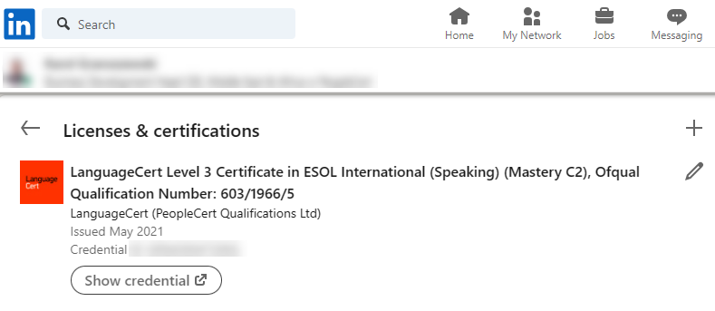

HOW TO REDEEM YOUR DISCOUNT/PROMO CODE
Discount/promo code: B02B4A (for students registering in Poland)
C4163A (for students registering outside Poland)
Saving on your exam fee is very simple:
- Go to www.languagecert.org
- Click the ‘For Test Takers’ tab on the website
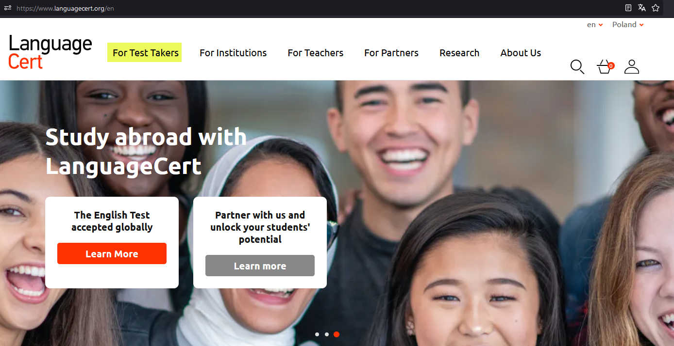
- Click the ESOL tab
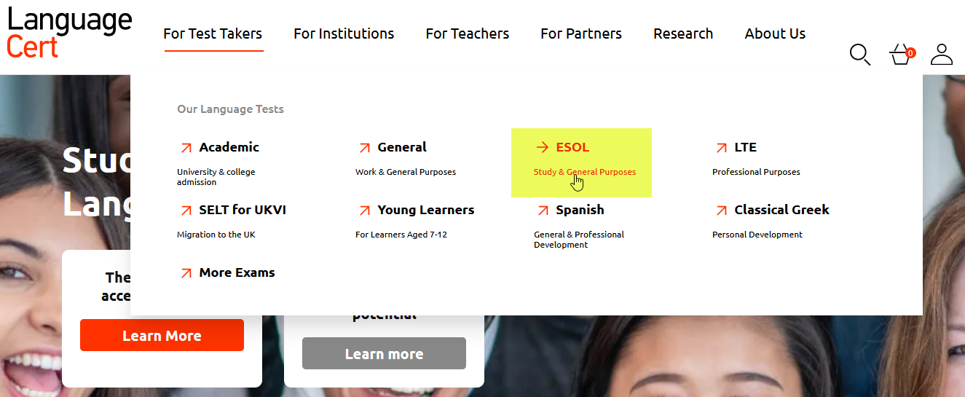
- Choose your ESOL level for example B2 Communicator and click Learn more
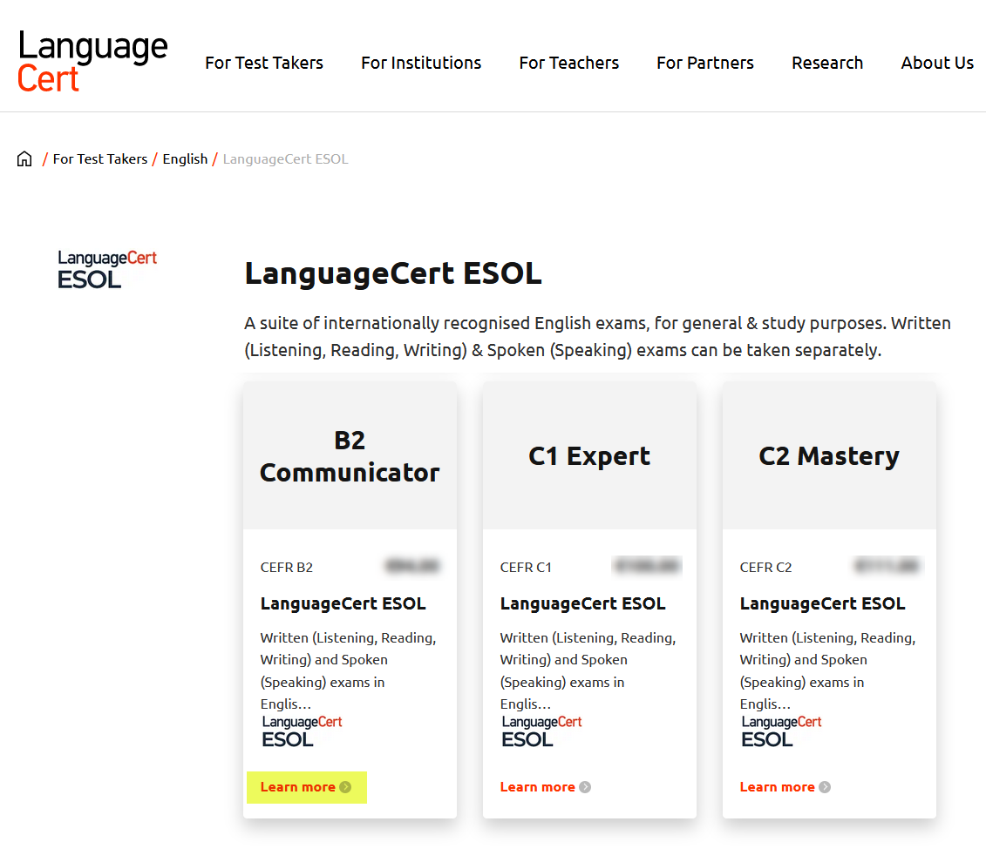
- Select the part of the exam you wish to take or select both Written and Spoken parts and click Book
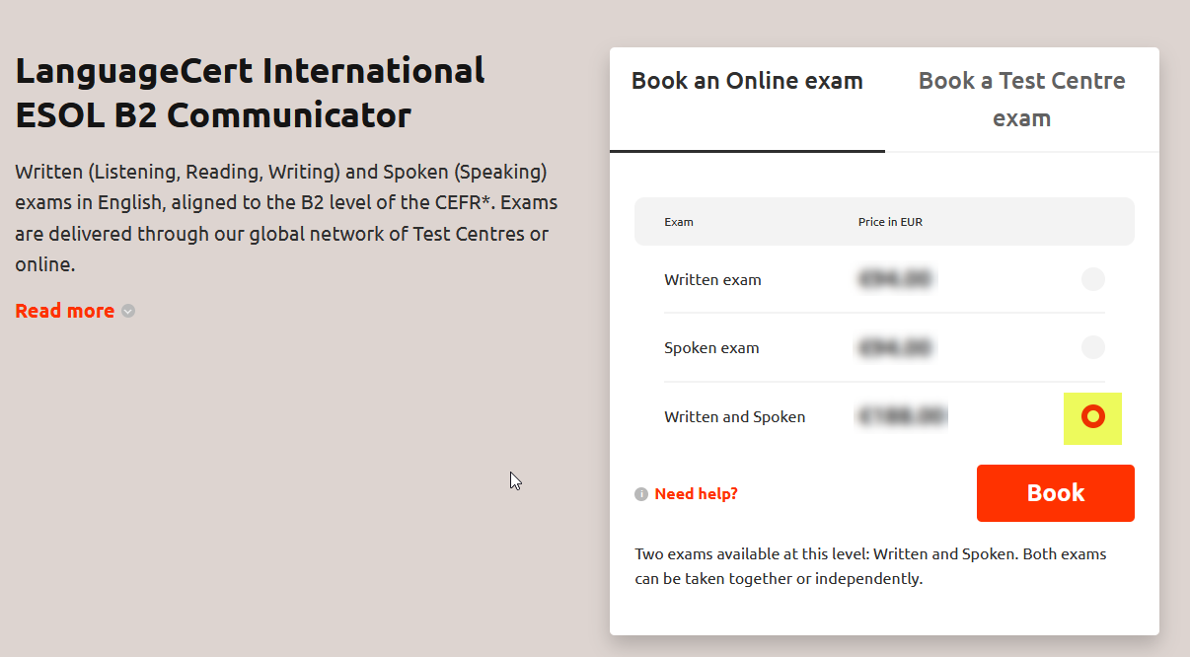
- Enter your promo code:
  - B02B4A (for students registering in Poland)
  - C4163A (for students registering outside Poland)
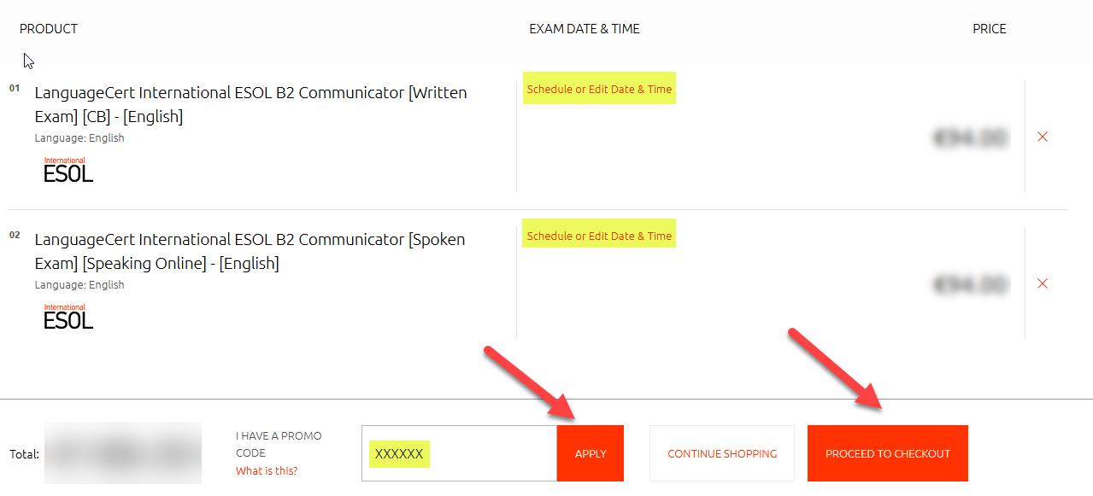

- Click Apply
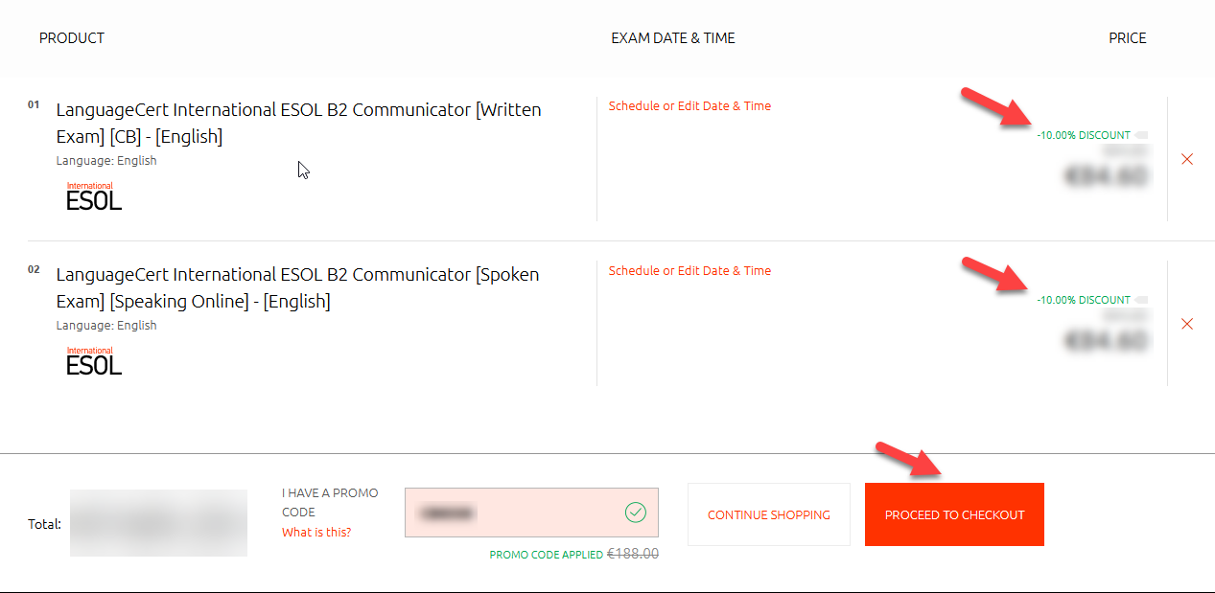
- Select your exam date and time (you can do this later as well)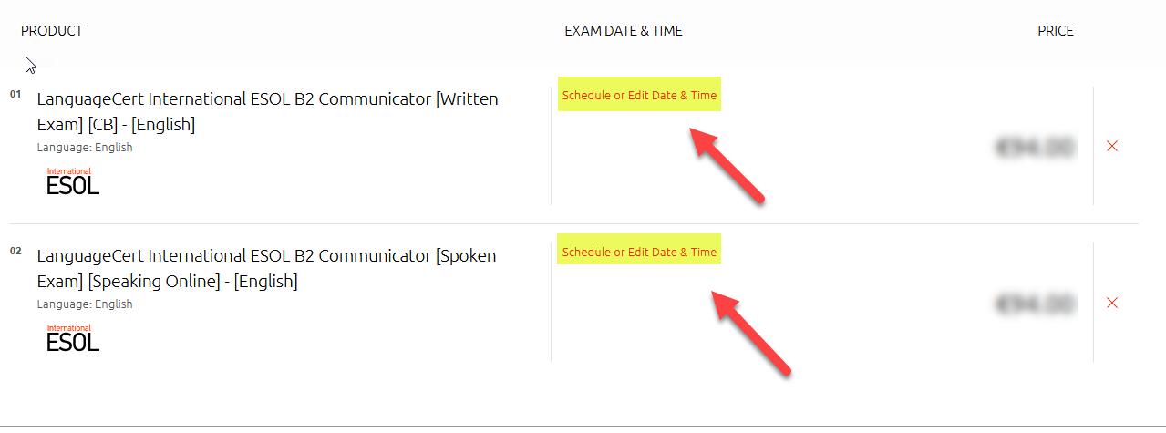
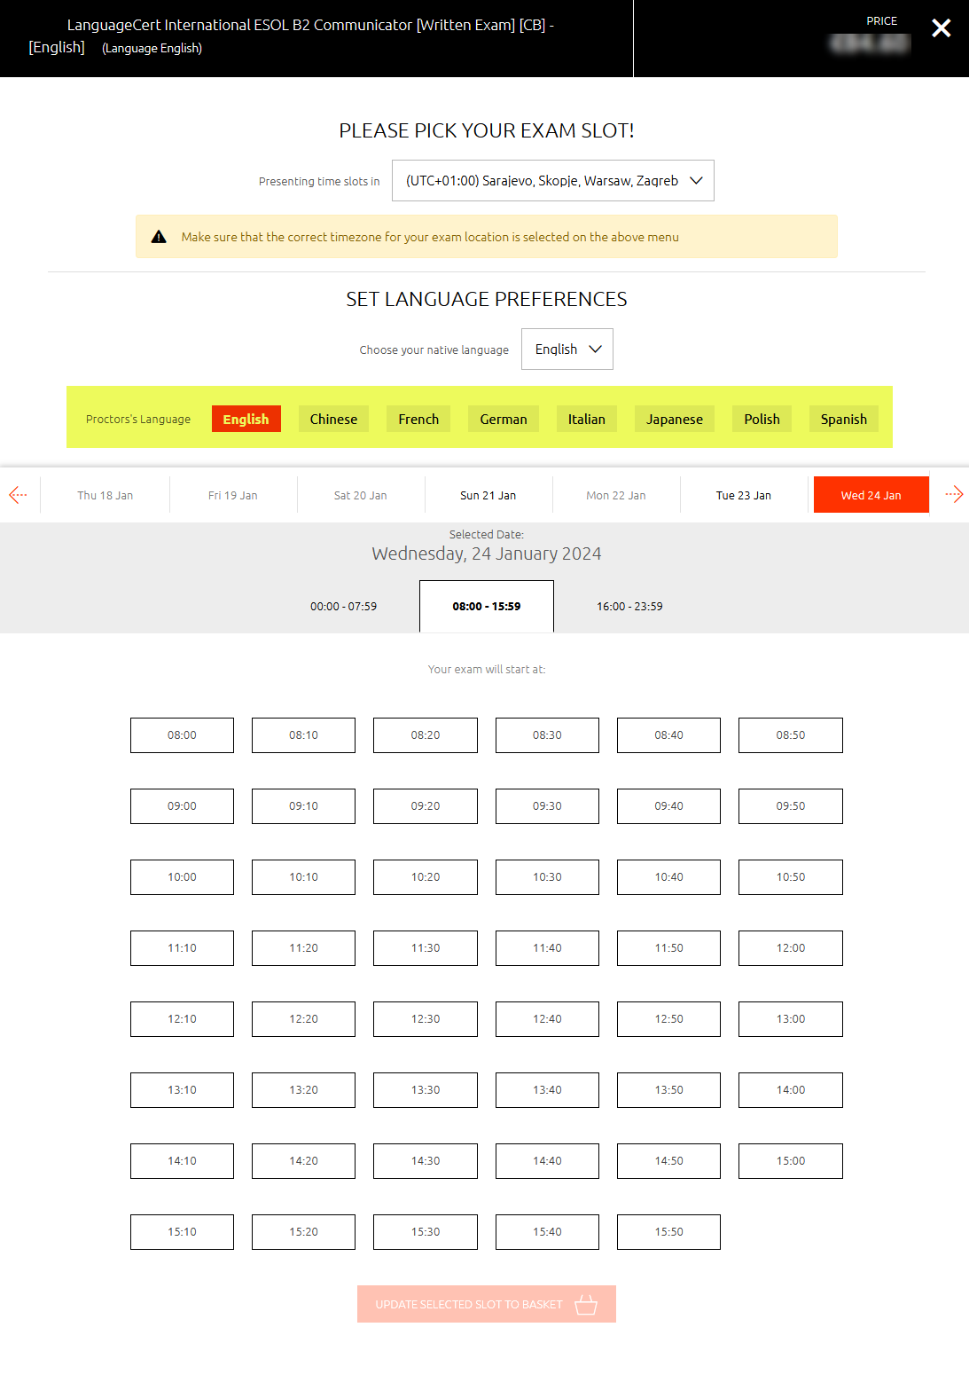
- Proceed to Checkout and complete your profile set up and registration
- Complete payment
- You will receive booking confirmation and additional instructions via e-mail
Tip: When you buy your exam, you will have 12 months from purchase to choose your exam date and time, depending on the availability of the exam slots. For the Written part (Listening + Reading +Writing) you can choose which language your test administrator will speak while taking you through the admin part of the exam – choosing your native language (if available) will reduce your exam stress

PREPARATION
LanguageCert International ESOL B2 (Communicator) preparation course!
Listening, Reading & Writing Tests cracked!
If you're planning to take an IESOL B2 Communicator exam or ESPECIALLY if you're already enrolled for it, this course is perfect for you.
Your promo code for the course purchase: LAC494 will award you 30% discount!
Click here for the Listening, Reading, Writing (Written) module preparation course:
https://lynkoacademy.podia.com/iesol-b2-communicator-written
Click here for Speaking module preparation course:
https://lynkoacademy.podia.com/iesol-b2-communicator-spoken
Sample tests, sample exam papers
There are sample tests available on LanguageCert website, you can download the exam packs here: https://www.languagecert.org/en/language-exams/english/languagecert-international-esol/b2-communicator-2281
… from the Official preparation material section of the website (scroll down).

Prepare your computer for the exam:
For your exam to be conducted successfully, you need to prepare your computer the right way, please see the guidelines below to help you prepare the technical part of the exam experience.
https://www.languagecert.org/en/exam-types/online-exams/olp-guidelines
Tip: Position your camera in such a way that you have the door to your room behind you so that the invigilator can see you and the door behind. Remove all the materials from your desk, put your phone on silent mode in case you will need to be contacted, do not switch it off entirely.

YOUR EXAM SCORES
You will receive from 0 to 50 points for each Part of the Written module of the ESOL exam (Listening, Reading, Writing) – a total of 0 to 150 points.
The passing score (pass mark) is 50% = 75 points, (Pass), 101+ points will award you High Pass. You will receive a Certificate for the Written module (Listening+Reading+Writing) separately from the IESOL Speaking exam.
Important: a total score from all exam parts counts towards your Pass or Fail score.
You will receive from 0 to 50 points from the Speaking module of the exam. The passing score (pass mark) is 50% = 25 points, 38+ points will award you High Pass.

WHAT WILL MY CERTIFICATE LOOK LIKE?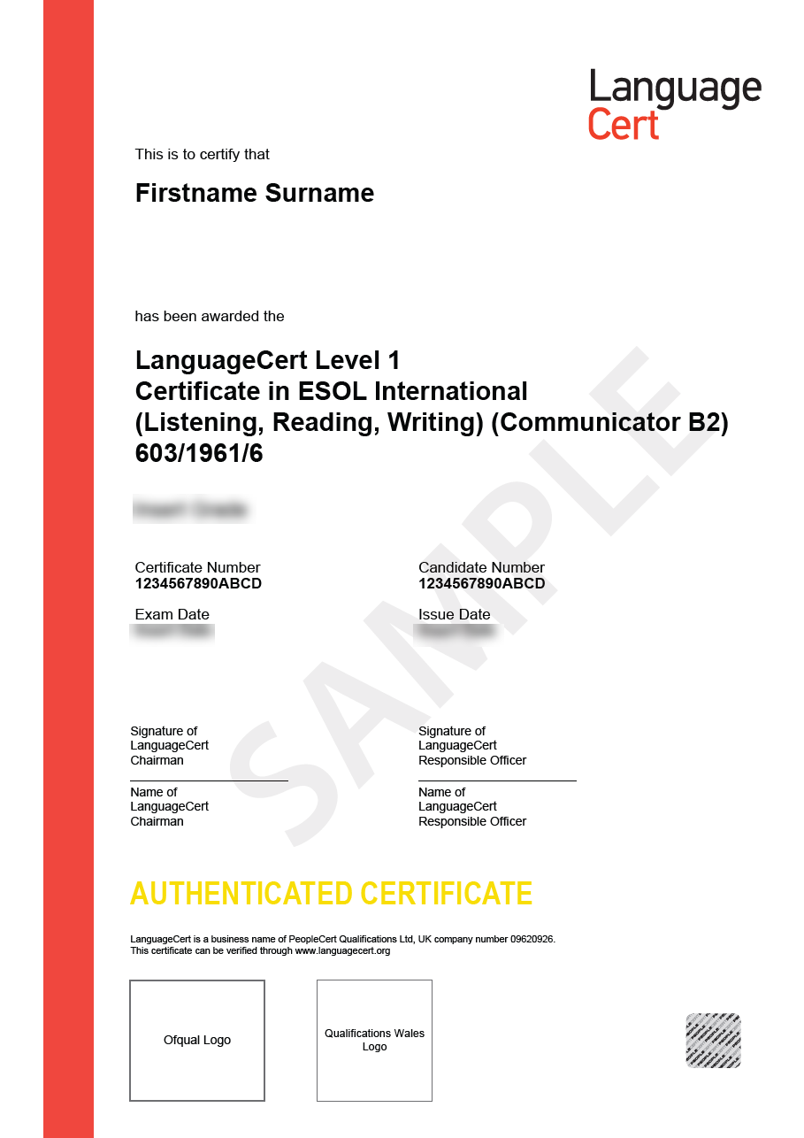
This is a sample Listening+Reading+Writing Certificate
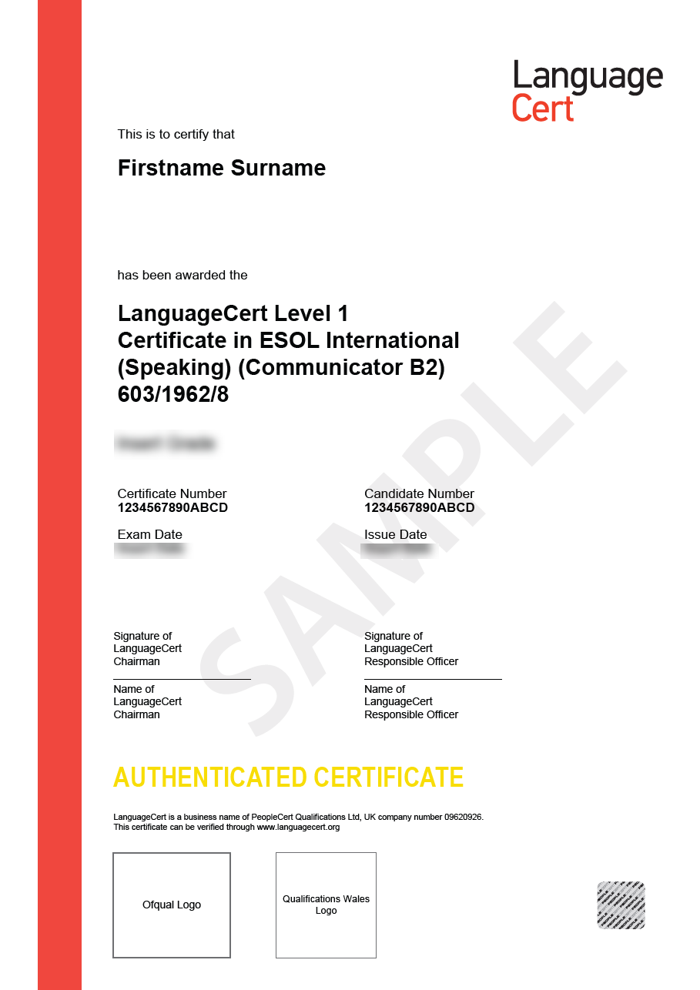
This is a sample Speaking Certificate

OTHER GREAT EXAM FEATURES

Online administration of the exams – Take IESOL at home!

See the introductory clip here: https://youtu.be/E-YBTMH5RZo?si=VUBkAb2KgliKxEDq
Online Live Proctoring means you schedule an appointment with your exam administrator online and connect live to take the exam in a secure and comfortable environment of your own room. With this exam delivery method, you save time and money, you have great flexibility in selecting your exam date and time and you take the exam 1 on 1 with your exam administrator. No need to adjust your schedule to other candidates or test center availability.
Tip:
You can decide to take the two IESOL modules at different times, for example: prepare for the Written Part (Listening, Reading and Writing) in the first semester/course and then prepare for the Speaking part and take it later. You can choose to take them on the same day as well, depending on the exam slots availability.

Take2 – exam re-sit option
Taking an English exam, like any exam, can be a bit stressful. Take2 allows you to re-sit the part of the exam in case of failing it, for an extra fee, a fraction of the exam price. You can only purchase the Take2 service during exam purchase and if you succeed the first time, it will not be refunded. For IESOL exam you can select Take2 for either the Written (Listening + Reading + Writing) module or the Spoken module or for both. Take2 will give you a sense of extra security and confidence.
Digital Badge from LanguageCert to boost your CV and profile!
You will surely impress your interviewer at your new college or your new job BUT the idea is to get invited! Adding the LanguageCert digital badge to your CV/resume and to your LinkedIn profile for example will definitely make you more visible in the pool of candidates. Once you pass your LanguageCert International ESOL exam, you will find your digital badge on your candidate’s profile, you can share or download your badge and use it to boost your profile!
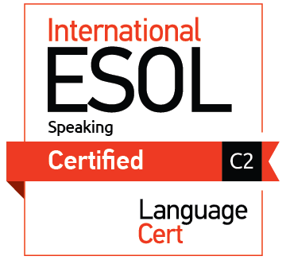

Other CEFR levels
Candidates from all over the world take LanguageCert IESOL B2 to study internationally and/or to include a proof of their English skills into their CVs/resumes and career portals like LinkedIn. B2 is the most popular level, however IESOL also offers other CEFR levels, for example B1 or C1 or C2.
Your promo codes will work for both lower and higher levels of IESOL examinations!
Click here to choose the level most appropriate for you: https://www.languagecert.org/en/language-exams/english/languagecert-international-esol
Discount/promo code: B02B4A (for students registering in Poland)
C4163A (for students registering outside Poland)

